## 6.Format the Text

**Create a functionality** that gets a text from **textarea**, formats the given **text** - you need to find out how many **sentences** there are in the text, simply **split** the whole text by **'.'**   
Also, every sentence must have at **least 1 character**.

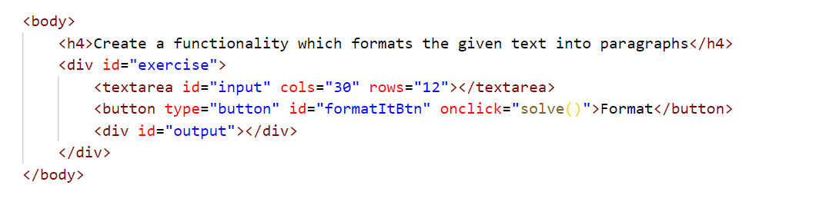

Generate HTML paragraphs as a string (Use interpolation **string** to create paragraph element: **`<p> {text} </p>`**) and append it to the div with an **id =** **"output"**.

When the [**Format**] button is **clicked**, get the text inside the **textarea** with an **id**="**input**" and **format it**. The formatting is **done** as **follows:**

* Create a **new paragraph element** that holds no more than **3 sentences** from the given input**.**
* **Hint: Use interpolation string to create paragraph element. (`<p> {text} </p>`)**
* If the given input contains **less** or **3 sentences**, you need to create only 1 paragraph, fill it with these sentences and append this paragraph to the div with an **id=**"**output**".

Otherwise, when you have more than 3 sentences**,** create enough paragraphs to get all sentences from the **textarea.**

Just remember to **restrict** the **sentences** in **each paragraph to 3.**

### Example:

* If the input textarea **contains 2 sentences**, create only **1 paragraph** with these 2 sentences

* If the input textarea **contains 7 sentences,** create **3 paragraphs**  
  - The **first paragraph** must contain **the first 3 sentences**  
  - The **second paragraph** must contain **the other three sentences** of the whole text  
  - The **third paragraph** will contain **only the last sentence**

### Output

|  |  |
| --- | --- |
| **Input** | **Output** |
| JavaScript, often abbreviated as JS, is a high-level, interpreted programming language. It is a language which is also characterized as dynamic, weakly typed, prototype-based and multi-paradigm. | <p>JavaScript, often abbreviated as JS, is a high-level, interpreted programming language. It is a language which is also characterized as dynamic, weakly typed, prototype-based and multi-paradigm.</p> |
| JavaScript, often abbreviated as JS, is a high-level, interpreted programming language. It is a language which is also characterized as dynamic, weakly typed, prototype-based and multi-paradigm. Alongside HTML and CSS, JavaScript is one of the three core technologies of the World Wide Web. JavaScript enables interactive web pages and thus is an essential part of web applications. The vast majority of websites use it, and all major web browsers have a dedicated JavaScript engine to execute it. As a multi-paradigm language, JavaScript supports event-driven, functional, and imperative (including object-oriented and prototype-based) programming styles. It has an API for working with text, arrays, dates, regular expressions, and basic manipulation of the DOM, but the language itself does not include any I/O, such as networking, storage, or graphics facilities, relying for these upon the host environment in which it is embedded. | <p>JavaScript, often abbreviated as JS, is a high-level, interpreted programming language.It is a  language which is also characterized as dynamic, weakly typed, prototype-based and multi-paradigm.Alongside  HTML and CSS, JavaScript is one of the three core technologies of the World Wide Web.</p> <p>JavaScript enables  interactive web pages and thus is an essential part of web applications.The vast majority of websites use it,  and all major web browsers have a dedicated JavaScript engine to execute it.As a multi-paradigm language,  JavaScript supports event-driven, functional, and imperative (including object-oriented and prototype-based)  programming styles.</p>  <p>It has an API for working with text, arrays, dates, regular expressions, and basic  manipulation of the DOM, but the language itself does not include any I/O, such as networking, storage, or  graphics facilities, relying for these upon the host environment in which it is embedded.</p> |